1. **次は前半がProgram 5のThink1、Think2の本文、後半はThink1、2の内容を聞いていたダニエルが自宅で弟のジョシュ(Josh)にクイズを出している場面です。読んで後の問いに答えなさい。**

**本　文**

１　健たちは，グループ発表をすることになりました。

Emily: I’ve found a good topic for our speech.

Ken: What is it?

Emily: It’s the history of chocolate.

Ken: Sounds interesting! There are many students who love chocolate in our class.

Emily: According to a website, the original chocolate was just a bitter drink.

Ken: A bitter drink? Really?

Emily: Yes. In the old times in Mexico, it was made from crushed cacao beans and spices. It had no sugar. People regarded it as medicine.

Ken: I didn’t know that.

Emily: Chocolate was so valuable that only a small number of people could have it.

２　現代のようなチョコレートがどのように生まれたのか，健が発表しています。

  How did chocolate become popular? Cacao beans were shipped to Europe by the Spanish in the 16th century. After that, Europeans began to drink their chocolate with sugar.

  The world’s first solid chocolate was made in 1847. However, it was still bitter. Then a Swiss man and his friend added milk to improve its taste. This is called “milk chocolate” today.

  Chocolate is enjoyed throughout the world now. Look at this figure. Let’s find the countries which consume a lot of chocolate.

**ダニエルの自宅にて**

Daniel: Josh, why don’t you enjoy a quiz?

Josh: Sure. I love answering a quiz. What kind of quiz?

Daniel: Quiz about chocolate. I know a lot about chocolate.

Josh: OK. Can you give me hard quiz? Here we go.

Daniel: Question 1. What was the original chocolate? Choose the (1)correct picture.

These are the pictures

Josh: Well…(2)this picture?

Daniel: Great! That’s the correct answer.

Josh: It’s easy for me. I’ve read a book about the history of Mexico.

Daniel: I see. But the next one is harder for you.

Question 2. What was **not** in the original chocolate?

ア.Spice イ.Sugar ウ.Medicine Choose one.

Josh: Too easy. ( 3 )

Daniel: Mmmmm…correct.

Josh: Give me harder one. That’s not interesting.

Daniel: Just a moment… OK. Question 3. ( 4 )

Josh: Solid chocolate.

Daniel: Oh, my god! That’s correct. Let’s talk about the original chocolate again.

Question 4. The original chocolate was not so popular in the old times. Why?

Josh: ( 5 )

Daniel: That’s a perfect answer. Next, question 5! Chocolate was still bitter in 19th century. What did a Swiss man and his friend do ( 6 )

Josh: They put milk into chocolate. We call it “milk chocolate” today.

Daniel: Correct. Josh, you’ve done good job, but you can’t answer the next one. This is the final and the hardest quiz.

(7)Question 6. What is the country which produces chocolate most?

Josh: ※Germany. On the other hand, ※Switzerland is the country which

consumes chocolate most ※per person.

　※Germanyドイツ　Switzerlandスイス　per person一人当たり

Daniel: Exactly. What a smart brother, Josh!

Josh: Daniel, can you answer my quiz? I want to give you three hints quiz!

Daniel: OK. Come on!

Josh: ( 8 )

* 1. 下線部(1)correctと同じ意味の英単語を記号で選びなさい。

アcolor イright ウbad エhowever

* 1. 下線部(2)this pictureが指す絵を記号で選びなさい。

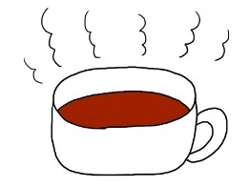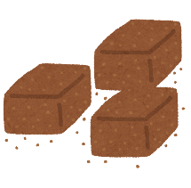ア　　　　　　　　　　　イ　　　　　　　　　　　ウ　　　　　　　　　　　エ

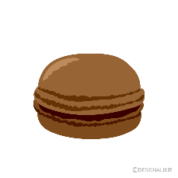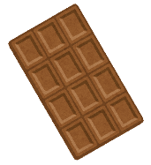

* 1. ( 3 )に入る言葉をア～ウから記号で選びなさい。
  2. ( 4 )に入るクイズとして最も当てはまるものを記号で選びなさい。

アWhat kind of chocolate was invented in 1847?

イWhat was shipped to Europe by the Spanish in the 16th century?

ウWhat did Europeans put into chocolate drink?

エWho introduced cacao beans to Europe?

* 1. ( 5 )に入る言葉を記号で選びなさい。

アA lot of people could have it because it was cheap.

イA lot of people could have it because it was sweet.

ウA small number of people could have it because it was bitter.

エOnly small number of people could drink it because it was valuable.

* 1. ( 6 )に入る**４語の英語**を本文の中から抜き出して書きなさい。
  2. 下線部(7)Question 6を考えるに当たって、ジョシュは下の表を思い出していました。表中でスイスはどれか、（ア）～（エ）の記号で答えなさい。



* 1. ( 8 )に入るthree hints quizを以下の条件に従って書きなさい。

【条件】 ①答えは、人物、キャラクター、動物など自由に設定する。（答えも書くこと）

②ヒント１つにつき1文、全部で3文書くこと。

③3つのヒントのうち、2つ以上は**関係代名詞**を使用すること。